DB and Table Creation:
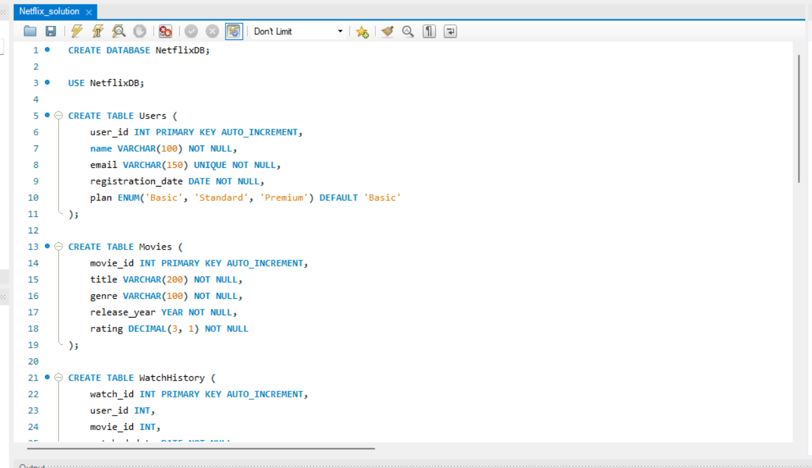
DATA INSERTION
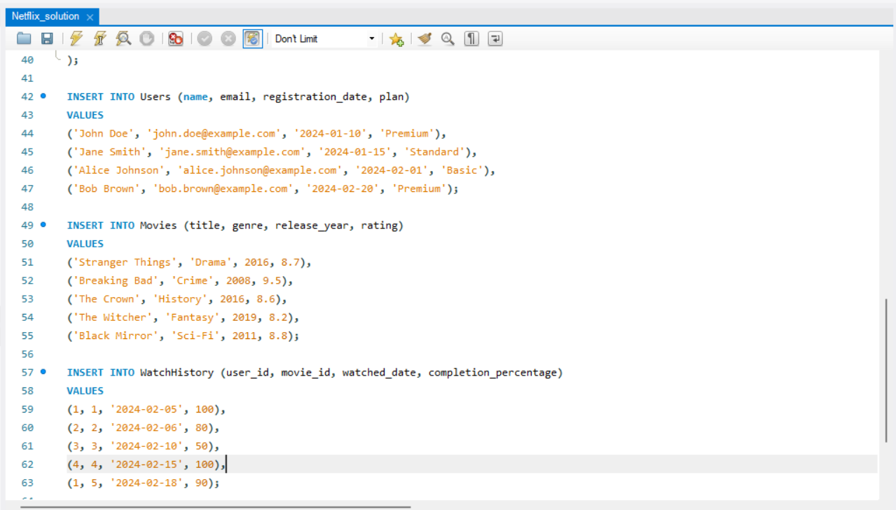

1. List all users subscribed to the Premium plan:
SELECT name,email FROM users WHERE plan='Premium';
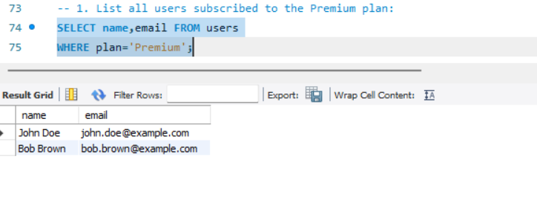
2. Retrieve all movies in the Drama genre with a rating higher than 8.5:
SELECT title, genre, rating FROM Movies where genre='Drama' AND rating > 8.5;
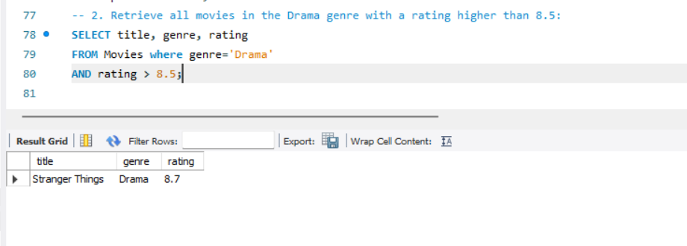
3. Find the average rating of all movies released after 2015:
SELECT avg(rating) as avg_rating
FROM Movies where release_year>2015
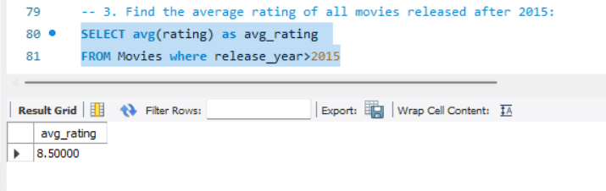

4. List the names of users who have watched the movie Stranger Things along with their completion percentage:
SELECT u.name, w.completion_percentage
FROM Movies V JOIN WatchHistory w
ON V.movie_id=w.movie_id
JOIN Users u ON w.user_id = u.user_id
where v.title='Stranger Things';
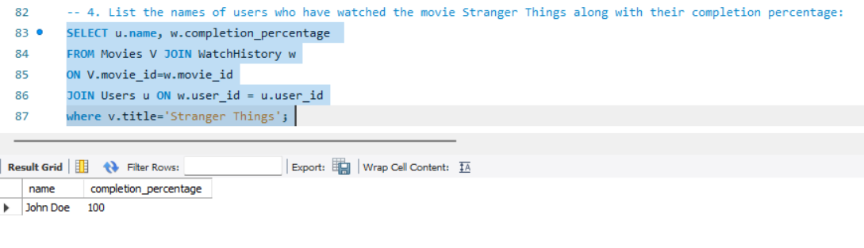

5.Find the name of the user(s) who rated a movie the highest among all reviews:
SELECT u.name, r.rating FROM
Users u JOIN Reviews r
ON u.user_id = r.user_id
WHERE r.rating = (SELECT max(rating) from Reviews);

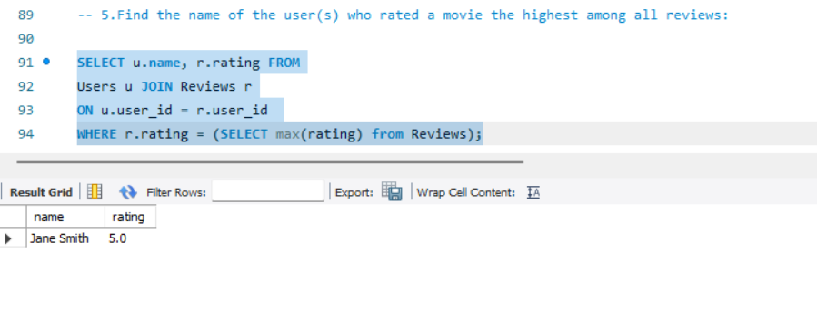
6. Calculate the number of movies watched by each user and sort by the highest count:
SELECT u.name, count(w.movie_id) as number_of_movies
from WatchHistory w JOIN Users u
ON w.user_id = u.user_id
group by u.name
ORDER BY number_of_movies desc
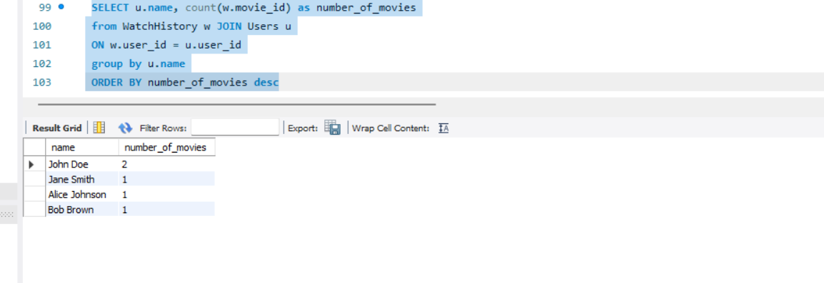
-- 7.List all movies watched by John Doe, including their genre, rating, and his completion percentage:
SELECT u.name, m.title, m.genre, m.rating, w.completion_percentage
FROM Users u JOIN WatchHistory w
ON u.user_id=w.user_id
JOIN Movies m
ON m.movie_id=w.movie_id
where u.name='John Doe'
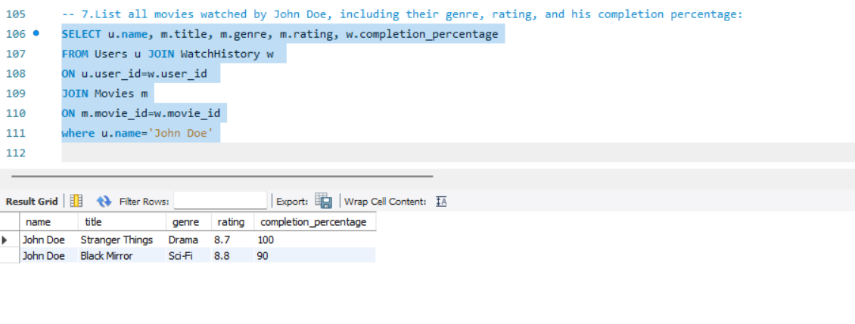
-- 8.Update the movie's rating for Stranger Things:
SELECT * FROM Movies WHERE title='Stranger things';
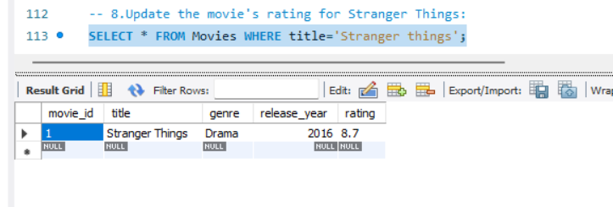
Update Movies
Set rating=9.0
where title='Stranger things';

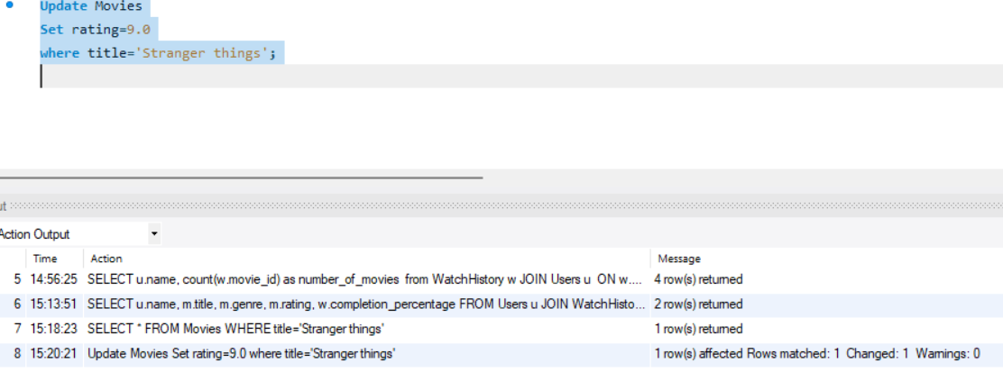
Value updated in the Movies table as shown
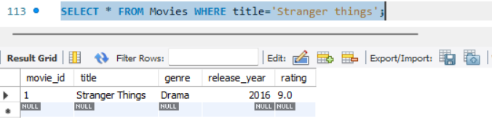

9.Remove all reviews for movies with a rating below 4.0:
SELECT * FROM Reviews;
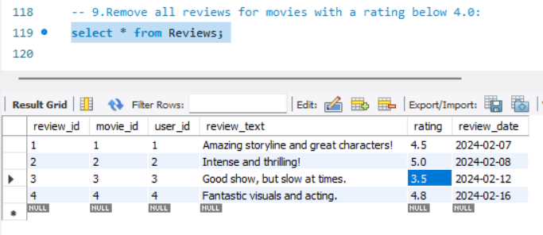

DELETE FROM Reviews
WHERE rating<4.0
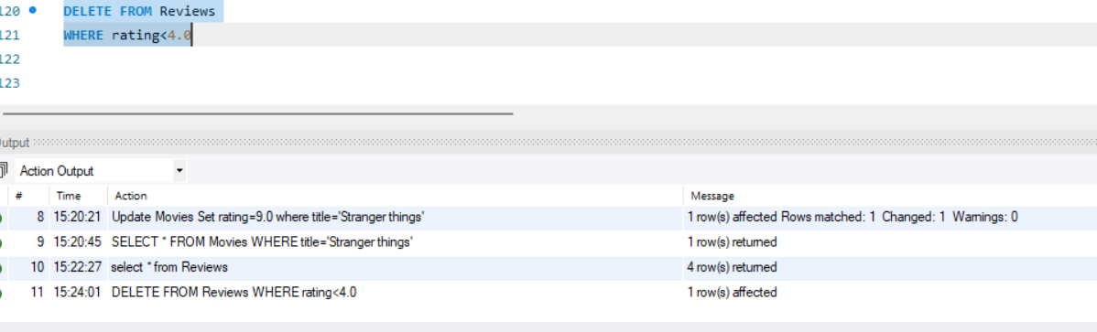
Rows with rating below 4.0 got deleted
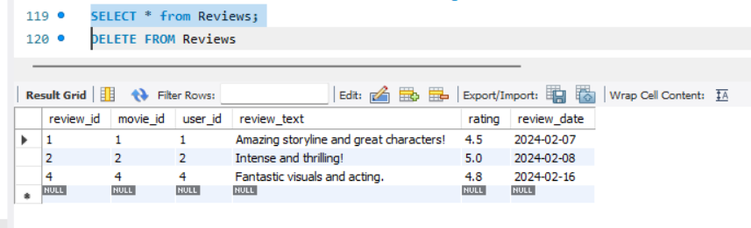

-- 10. Fetch all users who have reviewed a movie but have not watched it completely (completion percentage < 100):
Select name from Users U
JOIN Reviews R
ON U.user_id=R.user_id
JOIN WatchHistory W
ON W.movie_id = R.movie_id
WHERE completion_percentage<100;
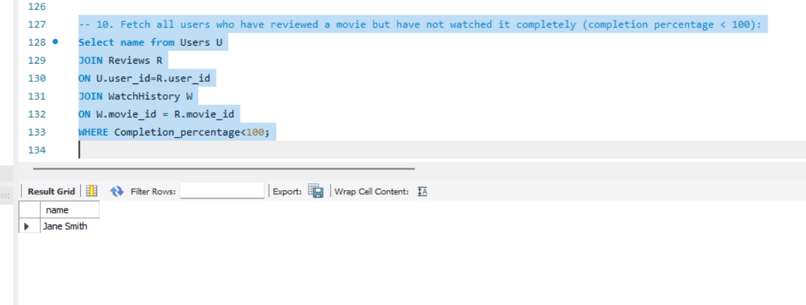
11. List all movies watched by John Doe along with their genre and his completion percentage:
SELECT u.name, m.title, m.genre, w.completion_percentage
FROM Users u
JOIN WatchHistory w
ON u.user_id=w.user_id
JOIN Movies m
ON m.movie_id=w.movie_id
where u.name='John Doe'
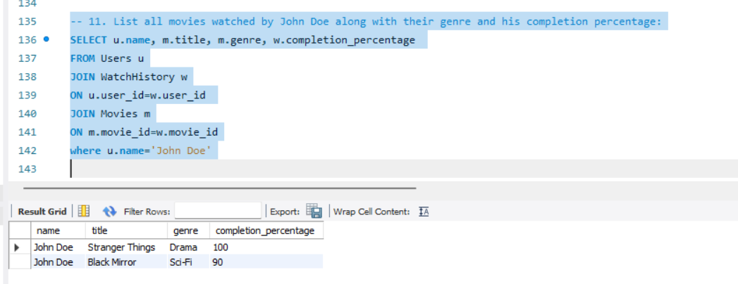

-- 12. Retrieve all users who have reviewed the movie Stranger Things, including their review text and rating:
SELECT u.name, r.review_text, r.rating
FROM Users u JOIN Reviews r
ON u.user_id=r.user_id
JOIN Movies m
ON r.movie_id=m.movie_id
WHERE m.title='Stranger Things';
